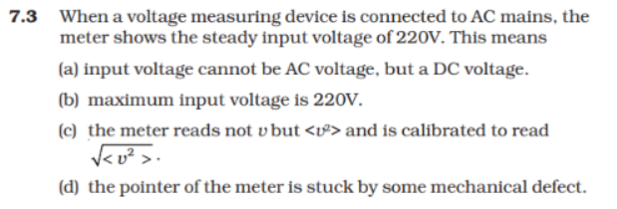

Answer:
c) Trivia: AC meters are different than DC meters. It is passed on power dissipation calculation.

